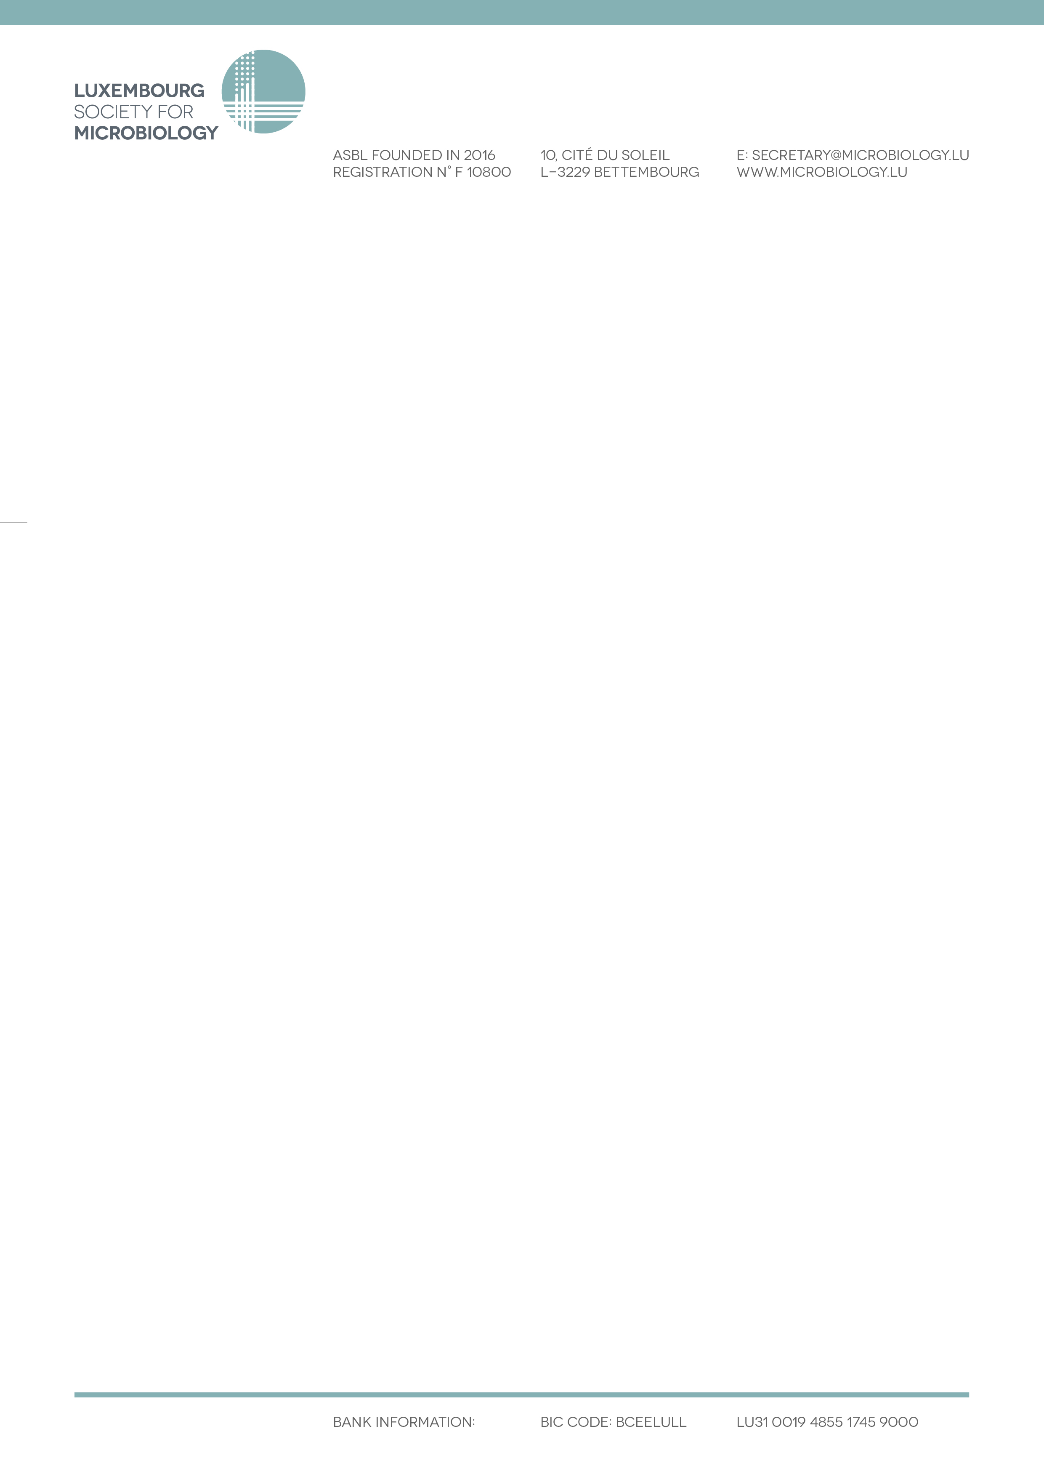

**8th Luxembourg Microbiology Day**

**May 13th 2025 @ LIH**

**Abstract submission form & guidelines**

From the submitted abstracts, the LSfM Scientific Committee will select 4 abstracts per each category (PhD and Researcher categories) for a 10-min presentation by the first author.

Abstracts not selected for oral presentation will be considered for poster presentation. The selected posters will be exhibited at the LMD and will also be presented as flash presentations (2 min each) by the first author.

**Submission deadline: April 14th 2025**

☐ PhD student category

☐ Researcher category

**Title (Tahoma, 12 Bold, Centered)**

Presenting Author1,*, Author2, Author1 (Tahoma, 10 Normal, Centered)

Affiliations

1Center for Microbiology, Department, City, Country (Tahoma, 10 Normal, Centered)

2University of Microland, Department, City, Country

*name.surname@mail.com

**Abstract**

Text (Tahoma, 10 Normal, Justified)

Max. number of words: 300

Description of the project (context, objectives and originality/results/technology/novelty of the study);

Concept for presenting to the general non-specialist public (oral presentations duration: 10 minutes).

**References (if any)**

J.W. Lennon, P. McCartney, G. Harrisson, R. Starr (2021) Why microbiology and rock ’n’ roll are great. *Journal of Microbes and Beatles* **21**:1-10. (Tahoma, 10 Normal, Justified)

**Acknowledgements (if any)**

Text (Tahoma, 10 Normal, Justified)