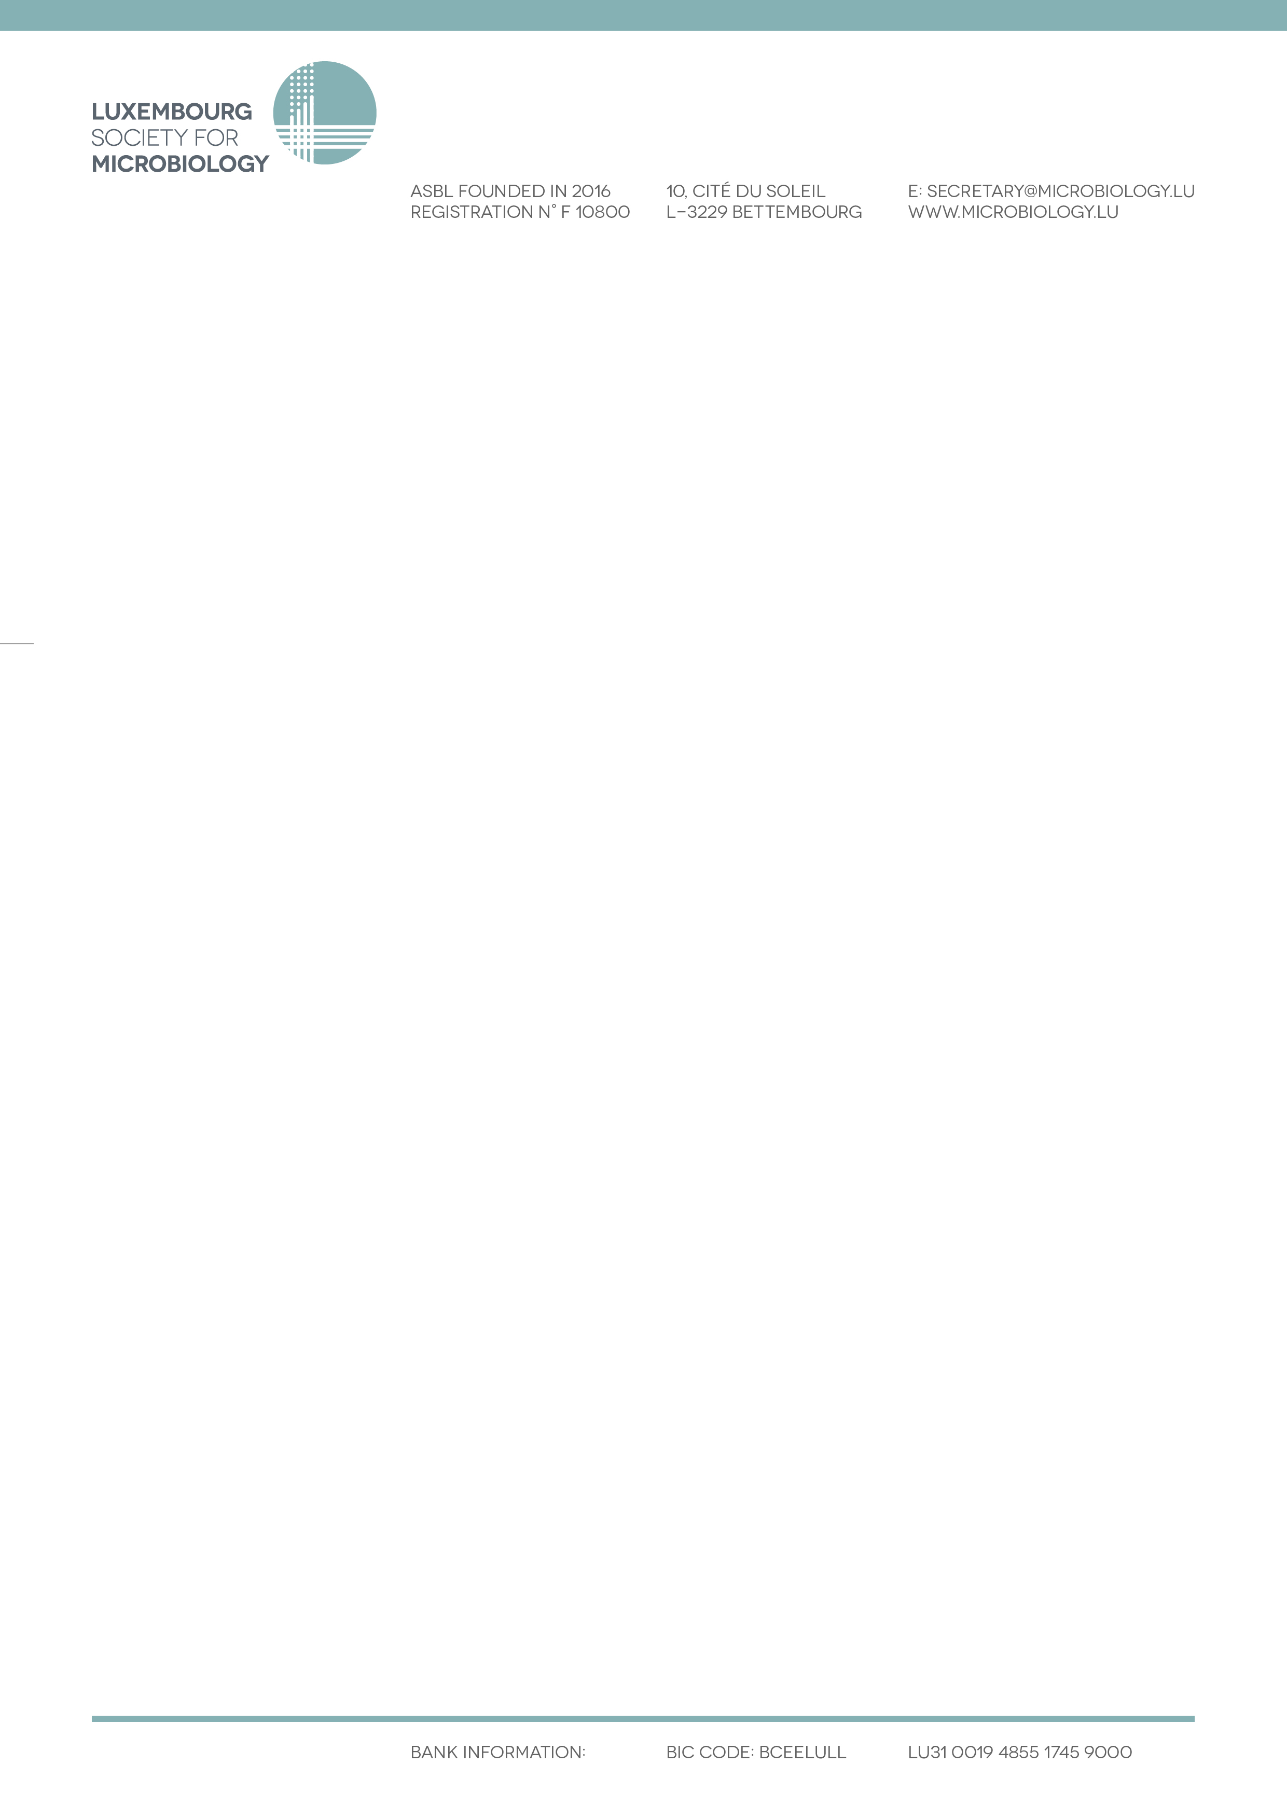

**8th Luxembourg Microbiology Day**

**May 13th 2025 @ Luxembourg**

**Abstract poster submission form & guidelines**

All posters will be exhibited at the LMD and also presented as flash presentations (2 min each) by their first authors.

Among the submitted abstracts, the LSfM scientific committee will select 4 abstracts for each category for a 10 min-presentation by their first authors

**Submission deadline: April 14th 2025**

☐ PhD student category

☐ Researcher category

**Title (Tahoma, 12 Bold, Centered)**

Presenting Author1,*, Author2, Author1 (Tahoma, 10 Normal, Centered)

Affiliations

1Center for Microbiology, Department, City, Country (Tahoma, 10 Normal, Centered)

2University of Microland, Department, City, Country

*name.surname@mail.com

**Abstract**

Text (Tahoma, 10 Normal, Justified)

Max. number of words: 300

Description of the project (context, objectives and originality/results/technology/novelty of the study);

Concept for presenting to the general non-specialist public (oral presentations duration: 10 minutes).

**References (if any)**

J.W. Lennon, P. McCartney, G. Harrisson, R. Starr (2021) Why microbiology and rock ’n’ roll are great. *Journal of Microbes and Beatles* **21**:1-10. (Tahoma, 10 Normal, Justified)

**Acknowledgements (if any)**

Text (Tahoma, 10 Normal, Justified)